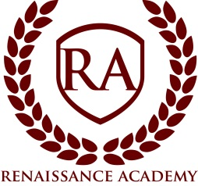

Board Meeting Agenda

Date: Wednesday, May 15, 2019
Time: 7:00 pm
Location: Renaissance Academy; 3435 North 1120 East, Lehi, UT. Public is welcome.
- Session Opens 7:00pm*
- Welcome and Call to Order: Ryan Hunter, Board Chair
- Roll call
- Approval of Minutes
- Executive Director Update
  - Financial Review
  - Global Governance Policy
  - Wellness Policy Discussion
  - Review Local Health Statistics
  - RISE Testing Update
  - 2019-20 Staffing
  - Intro to Curriculum Review Process
  - Remodel Project Presentation
  - Review Meeting Calendar for next month
- Items of Business
  - Vote on Wellness Policy
- Closed Session - A closed meeting described under Section 52-4-204 will be held for: (a) discussion of the character, professional competence, or physical or mental health of an individual and (d) strategy session to discuss the purchasing, exchange, lease or sale of real property.”

*All times are approximate and the board reserves the right to vote on any item on the agenda.

