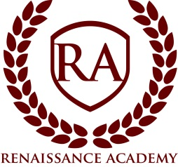

Board Meeting Agenda

Date: Wednesday, February 20, 2018
Time: 7:00 pm
Location: Renaissance Academy; 3435 North 1120 East, Lehi, UT. Public is welcome.
- Session Opens 7:00pm*
- Welcome and Call to Order: Ryan Hunter, Board Chair
- Roll call
- Approval of Minutes
- Executive Director Update
  - School Land Trust Video Training
  - Review School Charter and Goals
  - School Financial Review
- Items of Business
  - Read charter document Goals and Annual Goals
  - Doctor policy
- Closed Session - A closed meeting described under Section 52-4-204 will be held for: (a) discussion of the character, professional competence, or physical or mental health of an individual and (d) strategy session to discuss the purchasing, exchange, lease or sale of real property.”

*All times are approximate and the board reserves the right to vote on any item on the agenda.

