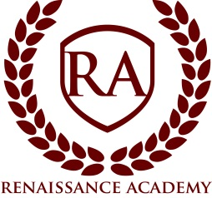

Board Meeting Agenda

Date: Wednesday, May 27, 2020
Time: 8:10 pm
Location: Renaissance Academy; 3435 North 1120 East, Lehi, UT. Public is welcome.
- Session Opens 8:10pm*
- Welcome and Call to Order: Ryan Hunter, Board Chair
- Roll call
- Approval of Minutes
- Executive Director Update
  - Annual Director’s Report
- Items of Business
  - Vote on a Bond Resolution
  - Approval of a Construction Project Budget

- Closed Session – “A closed meeting described under Section 52-4-204 will be held for: (a) discussion of the character, professional competence, or physical or mental health of an individual and (d) strategy session to discuss the purchasing, exchange, lease or sale of real property.” (section 52-4-205)

*All times are approximate and the board reserves the right to vote on any item on the agenda.

