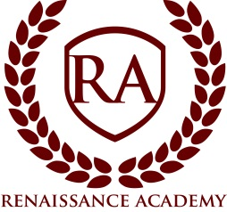

Board Meeting Agenda

Date: Wednesday, November 20th, 2019
Time: 7:00 pm
Location: Renaissance Academy; 3435 North 1120 East, Lehi, UT. Public is welcome.
- Session Opens 7:00pm*
- Welcome and Call to Order: Ryan Hunter, Board Chair
- Roll call
- Approval of Minutes
- Executive Director Update
  - Eagle Scout Project Presentation
  - Director Operational Update
  - DIBELS Beginning of Year Scores
  - Review of 2019 Audit & Form 990
  - Financial Update
  - Bond Refinance Review
  - Summary of Refinance/Remodel Purchasing Initiatives
- Items of Business

- Closed Session – “A closed meeting described under Section 52-4-204 will be held for: (a) discussion of the character, professional competence, or physical or mental health of an individual and (d) strategy session to discuss the purchasing, exchange, lease or sale of real property.” (section 52-4-205)

*All times are approximate and the board reserves the right to vote on any item on the agenda.

