SY 2025-2026

For Immediate Release

Contact: Stella Aires
(801)768-4202x5112
saires@rencademy.0rgEmail

National School Lunch, School Breakfast and Special Milk Programs

Lehi, UT – Renaissance Academy today announced their policy for free and reduced-price meals and free milk for children unable to pay the full price of meals/milk served under the National School Lunch, School Breakfast, After School Snack, and/or Special Milk programs. If the Local Education Authority (LEA) participates in the program, they will have a copy of the policy, which may be reviewed by any interested party. Renaissance Academy will be distributing program information and accepting free and reduced-price applications after July 1st for the 2025-2026 school year.
The household size and income criteria used for determining eligibility this year is listed below. Children from households whose income is at or below the levels shown are eligible for free or reduced-price meals/free milk.
Children or households currently approved for Food Stamps (SNAP), Food Distribution Program on Indian Reservations (FDPIR), Family Employment Program (FEP), or some Medicaid programs are eligible for free or reduced meal or milk benefits. There are two ways the household may qualify for free meals: 1) The LEAs will approve these children for free meals through the direct certification process and no application is required for free meal benefits or, 2) The household may contact the LEA and indicate the qualifying assistance program in which they participate.
Households will be notified by the LEA of their eligibility and children will be provided free meal benefits unless the household notifies the school that it chooses to decline benefits. All children in these households are eligible for free meal benefits and if any child(ren) was not listed on the eligibility notice, the household should contact the school to have benefits extended to that child(ren). If the child(ren) or household receives benefits under Assistance Programs or other source programs and is not notified by the school of their free meal benefits, the parent or guardian should contact their school.
Application forms or instructions to complete an online application form for those not directly certified have been sent home including a letter to parents or guardians. To apply for free or reduced-price meals or free milk, households should fill out the application and return it to their school or district office. The information provided on the application will be used for the purpose of determining eligibility and may be verified at any time during the school year by school or other program officials. Children’s names, eligibility status and other information provided on the paper application or obtained through direct certification may be disclosed to certain other Federal, State, or local agencies as authorized by the National School Lunch Act (NSLA).
For the school officials to determine eligibility, the household must provide the following information listed on the application: names of all household members; last four digits of the Social Security Number of the adult completing the application, or a statement that the person does not possess one; the income received by each household member with income frequency and income source noted; and the signature of an adult household member certifying that the information provided is correct.
Applications may be submitted at any time during the year to the school. If a household member becomes unemployed or if the household situation changes, the family should contact the school. Such changes may make the children of the household eligible for free or reduced-price meals or free milk.
Under the provisions of the free and reduced-price policy, a designated approving official at the LEA will review applications and determine eligibility. If a parent or guardian is dissatisfied with the ruling of the official, (s)he may wish to discuss the decision on an informal basis with the approving official. If the parent or guardian wishes to make a formal appeal, (s)he may make a request either orally or in writing to the LEA hearing official by contacting the local school food service supervisor for more information. The policy contains an outline of the hearing procedure.
Foster children who are legal wards of the court or state are eligible for free meal benefits. If a household has foster children and wishes to apply for meal benefits for such children, the household should complete the application.
When known to the LEA, households will be notified of any child’s eligibility for free meals if the individual child is Other Source Categorically Eligible because the child is categorized as: homeless, migrant or runaway as defined by law; or enrolled in an eligible Head Start, Even Start (pre-school and pre-kindergarten children) as defined by law.
The information provided by the household is confidential and will be used only for purposes of determining eligibility and verifying data, unless a waiver releasing the use of the information for other specific programs is signed by the parent or guardian. Families directly certified will receive a waiver release form for their signature with the notification letter. The household name and address will be given to the Children’s Health Insurance Program (CHIP) unless “No” is checked on the back of the application.
Supplemental Nutrition Program for Women, Infants & Children (WIC) may be eligible for free or reduced-price meals. Individuals should complete an application for free and reduced-price meals and return it to the school where the child is enrolled. The family will be notified of the child’s eligibility.
In accordance with federal civil rights law and U.S. Department of Agriculture (USDA) civil rights regulations and policies, this institution is prohibited from discriminating on the basis of race, color, national origin, sex (including gender identity and sexual orientation), disability, age, or reprisal or retaliation for prior civil rights activity.
Program information may be made available in languages other than English. Persons with disabilities who require alternative means of communication to obtain program information (e.g., Braille, large print, audiotape, American Sign Language), should contact the responsible state or local agency that administers the program or USDA’s TARGET Center at (202) 720-2600 (voice and TTY) or contact USDA through the Federal Relay Service at (800) 877-8339.
To file a program discrimination complaint, a Complainant should complete a Form AD-3027, USDA Program Discrimination Complaint Form which can be obtained online at https://www.usda.gov/sites/default/files/documents/ad-3027.pdf, from any USDA office, by calling (866) 632-9992, or by writing a letter addressed to USDA. The letter must contain the complainant’s name, address, telephone number, and a written description of the alleged discriminatory action in sufficient detail to inform the Assistant Secretary for Civil Rights (ASCR) about the nature and date of an alleged civil rights violation. The completed AD-3027 form or letter must be submitted to USDA by:
- mail:
U.S. Department of Agriculture
Office of the Assistant Secretary for Civil Rights
1400 Independence Avenue, SW
Washington, D.C. 20250-9410; or
- fax:
(833) 256-1665 or (202) 690-7442; or
- email:
program.intake@usda.gov

The Income Eligibility Guidelines for free and reduced-price school meals and free milk are shown below. These guidelines are used by schools, institutions, and facilities participating in the National School Lunch Program (and USDA Foods School Program), School Breakfast Program, Special Milk Program for Children, Child and Adult Care Food Program, Summer Food Service Program and The Emergency Food Assistance Program and are effective from July 1 through June 30 every year. The Income Eligibility Guidelines are also located online at https://www.fns.usda.gov/school-meals/income-eligibility-guidelines.

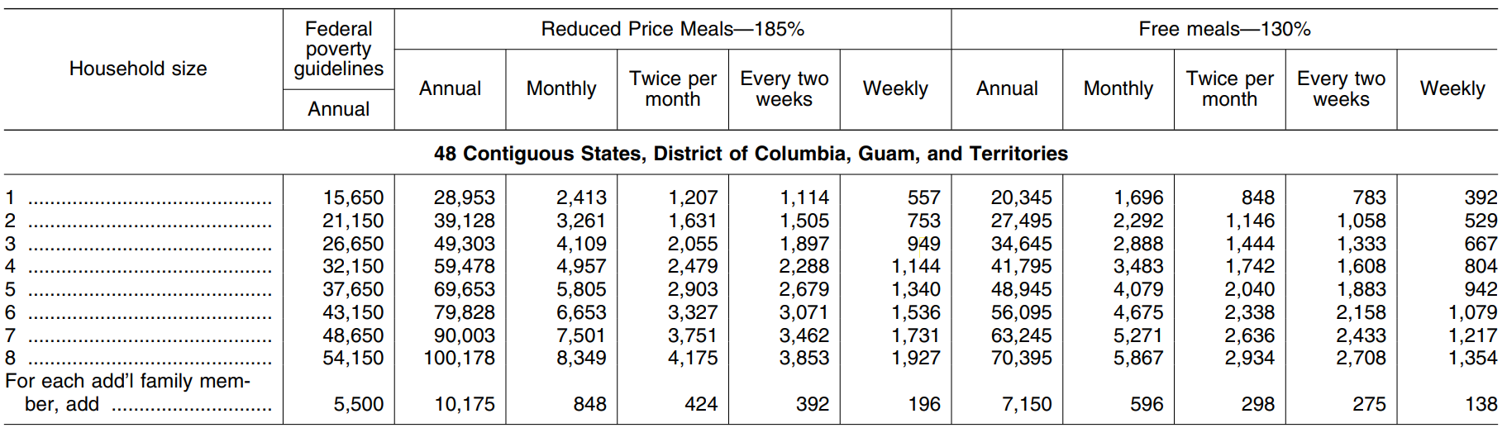
Income Eligibility Guidelines
Effective from July 1, 2025 – June 30, 2026

